HTML forms
Data exchange
Question:- Html form ⬅➔ Views.py
Returning the Html form when user hit the Submit button will be redirected to the different page
1st Create a Html Form in home .html like previously we did that
Home.html
Commented codes are for the createinng the Templates
<!-- <h1>
----- JAI SRI RAM ------
</h1><br>
<h1>
jai jai sri ram......... by OM
<br><br><br><br>

{{ name }}
</h1>
<h3> This is home.html file running</h3> -->
<h1> Word count in Django by OM</h1>
<form action="{% url 'count' %}">
<textarea name='fulltextarea' cols=60 rows=30></textarea>
<br/>
<input type="submit" value="Count"/>
</form>

----------------------------------------------------------------------
Urls.py
from wordcount import views
from django.urls import path
from . import views
urlpatterns = [
path('',views.homepage),
path('contact/',views.contact),
#path('count/',views.count),
path('counts/',views.count, name='count'),
]

Count.html <h1>Counted </h1> this is only 1 line to just checking for redirecting the page
----------------------------------------------------------------------
Views.py
from django.http import HttpResponse
from django.shortcuts import render
# this is used for returning some page when user hits a perticular page

#def homepage(request):
#return render(request,'home.html')

def homepage(request):
return render(request,'home.html',{'name':'Namatey ! am OM '})# passing dictionary also
#{ 'KEY ':'VALUE '} -- dictinary

def contact(request):
return HttpResponse('<h2>***** OM HANUMATEY NAMHA ******** this is CONTACT PAGE page page<br><h4>Returning with httpResponse</h4></h2>')

def count(request):
return render(request,'count.html')

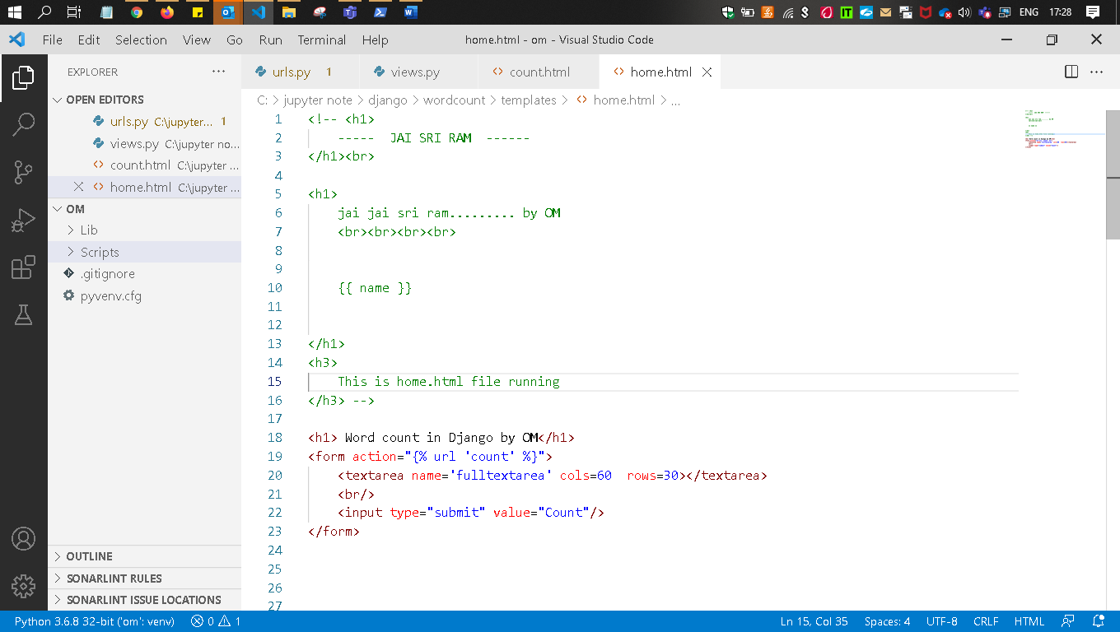
url.py
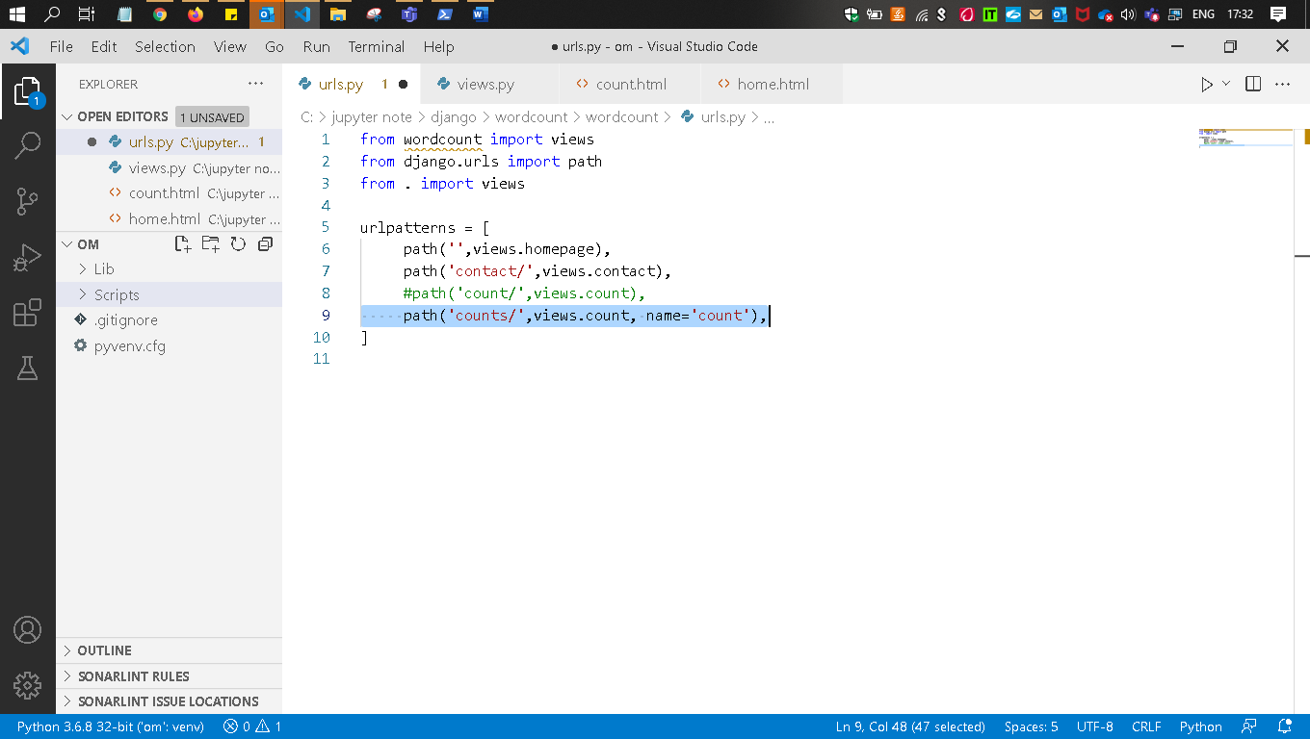
Count.html
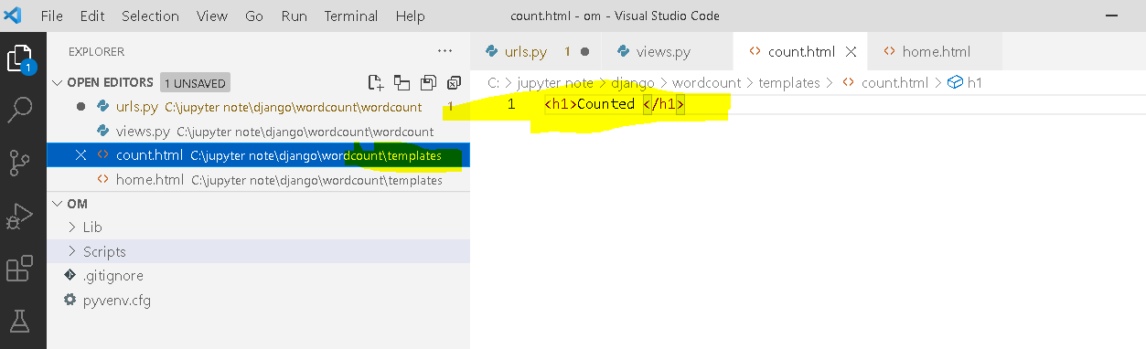

Views.py
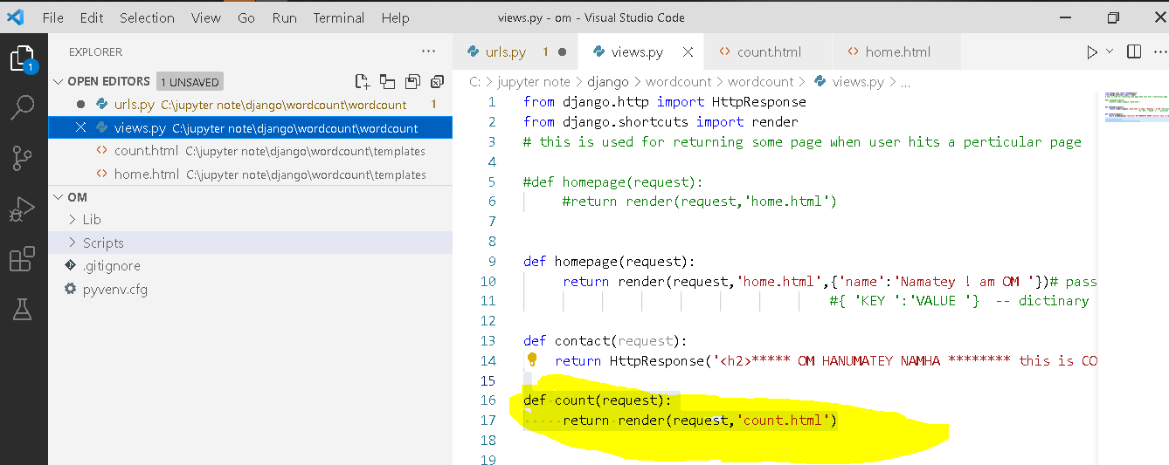

Fllowing of the
1.Run the server
Out put
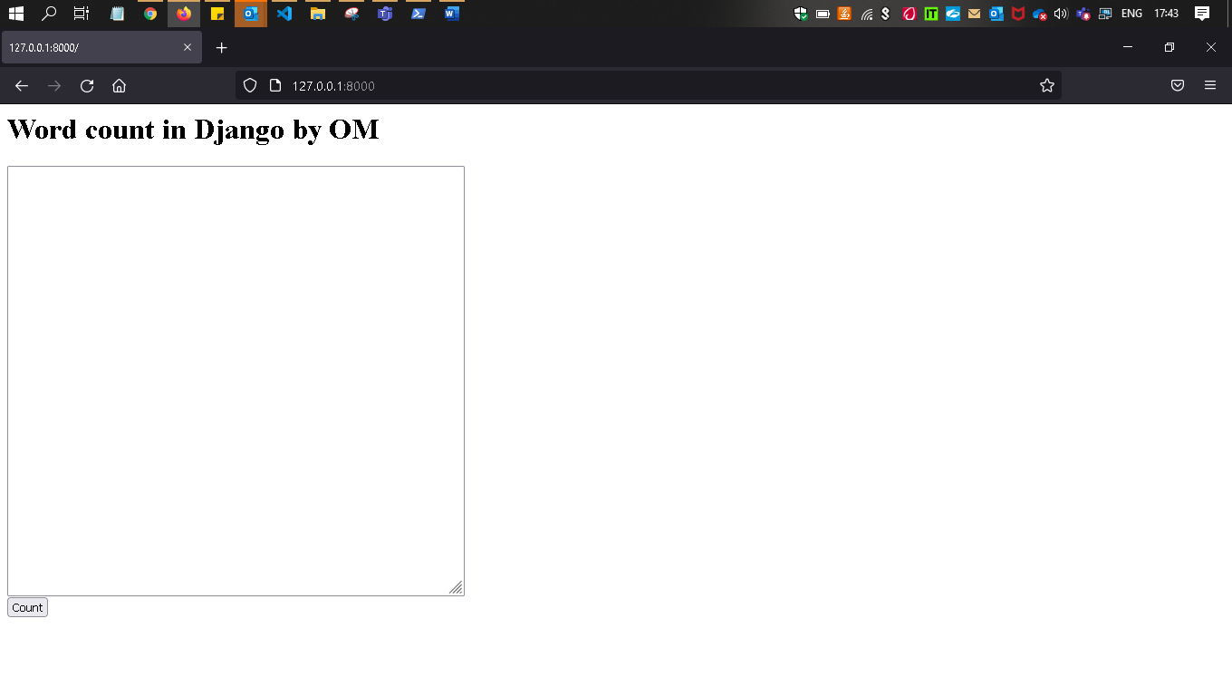
How
--→ Will checks into the url.py file
path('',views.homepage),------ path (‘’) means default domin name will inside that ------Views.py-- → homepage() function will excute which is returning home.html see below and above in fig. views.py

def homepage(request):
return render(request,'home.html')

go to the home.html

<h1> Word count in Django by OM</h1>
<form action="{% url 'count' %}">
<textarea name='fulltextarea' cols=60 rows=30></textarea>
<br/>
<input type="submit" value="Count"/>
</form>

textarea = to put the text ,text area through that you can resize it
input can’t be resize .

name='fulltextarea' ---- by this what ever you will write ,ll display into the Search area of the browser

<form action=”where you want to redirect” --
<form action="{% url 'count' %}"> looslly coupled
<form action="{'count’"> this is tightly couplled

'count’, {% url 'count' %} ---- these are the kind of pages
But user cn’t hit directly ,czz its redirecting After Submitting the form of Home.html

{% url 'count' %} ---- after submitting
Will go into URL.py---→and try to find any path which is path has the name=’count’

#path('count/',views.count),
path('counts/',views.count, name='count'), these two must be same else will get error at the default page and your project also not start -→czz ervy pages are connected to each other
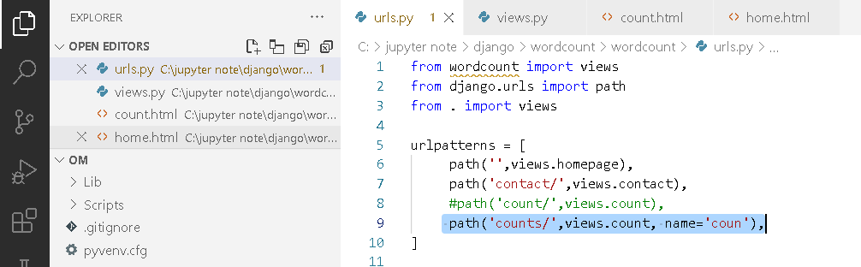

So its displing above screen short which is a op of home.html

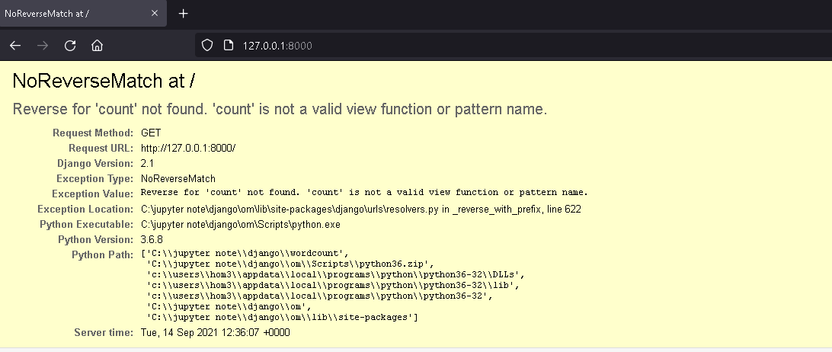

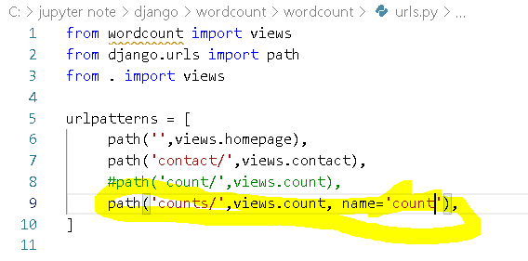
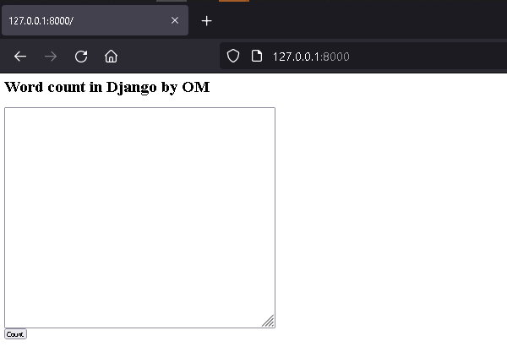
After make it correct output is

#path('count/',views.count), tightly coupled

<form action="count">
<textarea name='fulltextarea' cols=60 rows=30></textarea>
<br/>
<input type="submit" value="Count"/>
</form>

path('counts/',views.count, name='count'), here it checks with name as argument

<form action="{% url 'count' %}">
<textarea name='fulltextarea' cols=60 rows=30></textarea>
<br/>
<input type="submit" value="Count"/>
</form>

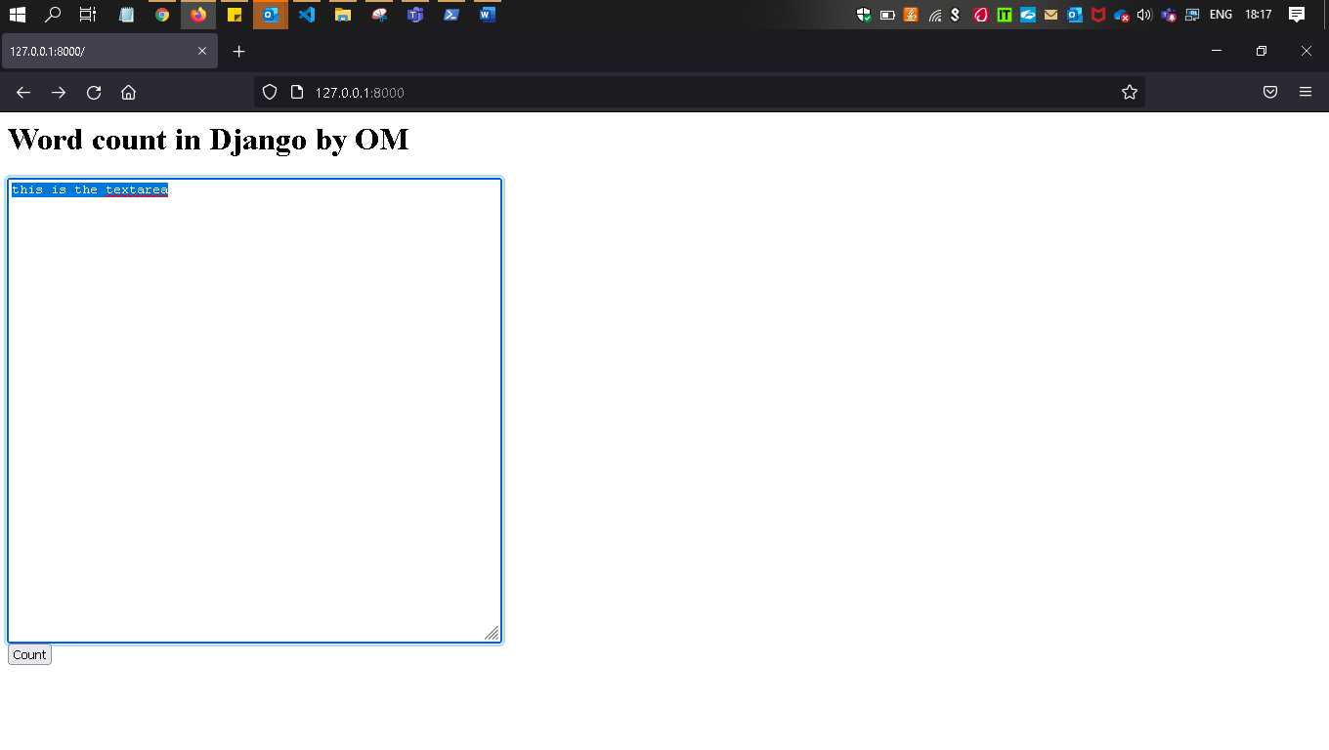
After hit the summit hutton
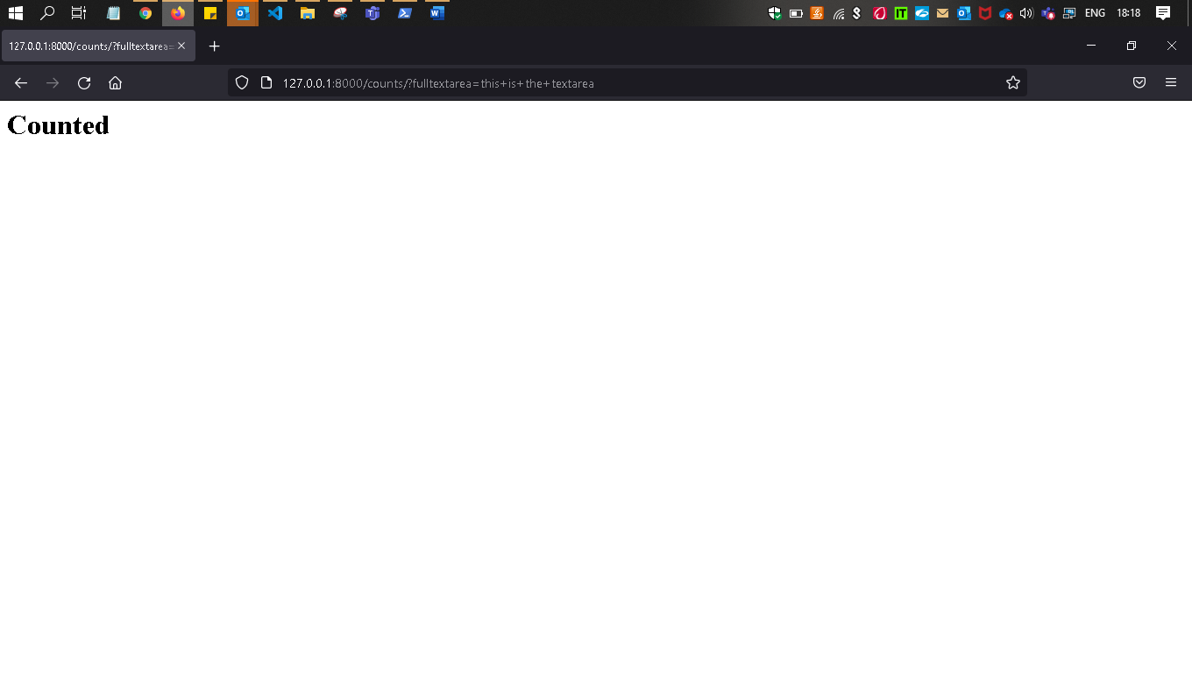
Because it will go and run the below function
path('counts/',views.count, name='count'),

next

def count(request):
return render(request,'count.html')

Next
Count.html
<h1>Counted </h1>

